***“He is Worth Exalting, Because of … What He Promises”***

**VI. What He Promises**

**A. Promise of Heaven**

John 14:1-3

1) A Mystery Revealed

“more sure way” - 2 Peter 1:16-19

2) A Personal Guarantee

3) A Corporate Experience

**B. Promise of Reward**

Luke 18:29-30

1) Context of Sacrifice/Hardship

2) Is Reward Unspiritual?

a) Motivation spoiler?

Hebrews 11:6

Matthew 6:3-4

Matthew 6:6

Matthew 6:17-18

Matthew 10:42

Luke 14:13-14

Luke 6:35

Matthew 6:19-20

b) Diminish Christ?

**C. The Promise of Abundant Life**

John 10:9-10

1) Two Lies

a) Can’t save me

1 Thessalonians 1:4; 1 Peter 2:9

b) ‘Abundant life’ is only for a select few

Romans 2:10-11; Galatians 2:6; 2 Corinthians 3:18

2) An Important Truth

Hebrews 4:2

**Quotes:**

*“In the written word are found all sorts of refreshing, strengthening and heart-reviving promises prepared by the wisdom and care of God for our relief in the days of darkness and trouble; promises of support under the heaviest burdens and pressures, Is. 41:10. “Fear not, for I am with you; be not dismayed, for I am your God; I will strengthen you, yes, I will help you, yes, I will uphold you with the right-hand of my righteousness.” A promise able to make the most timorous and trembling soul to shout with the joy of men in harvest…Let those that have no God to flee to, no promise to rely upon, let them fear in the day of evil, I have no cause to do so.”*  John Flavel

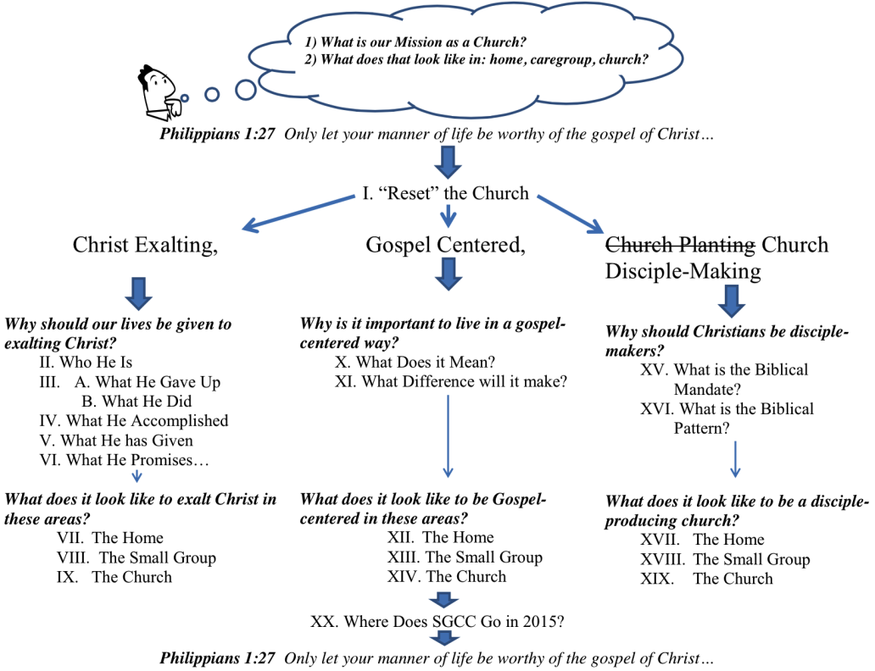*“The great difficulty with many Christians is that they cannot persuade themselves that Christ (or God) loves them; and the reason why they cannot feel confident of the love of God, is, that they know they do not deserve his love, on the contrary, that they are in the highest degree unlovely.  How can the infinitely pure God love those who are defiled with sin, who are proud, selfish, discontented, ungrateful, disobedient?  This, indeed, is hard to believe.”* Charles Hodge