**“Gospel Centered … *What Difference Will it Make?*”**

Part C – “Relationship”

**XII. *What Difference Will it Make?*”**

**A) Defines Our Identity**

**1) Misplaced Identity**

a) Learned:

Matthew 20:20-21; Mark 10:35-37

b) Owned:

Luke 9:52-55

**2) Our Privileged ID**

a) What the Bible Says

1 John 3:1

Romans 15:7

1 Corinthians 6:17

Ephesians 1:5

Jeremiah 1:5

b) Who we are

John 13:23, 20:2, 21:20

*“The love of Christ for me will get last say. He is merciful to me for his name’s sake, for the sake of his own goodness, for the sake of his steadfast love and compassion (Psalm 25). When he thinks about me, he remembers what he is like, and that is my exceeding joy. My indestructible hope is that he has turned his face towards me, and he will never turn away.”*   
― [David A. Powlison](https://www.goodreads.com/author/show/432227.David_A_Powlison)

**B) Guarantees a Father**

Deuteronomy 32:6; Isaiah 63:16; Matthew 6:9

John 20:17; Romans 8:15; Revelation 21:6-7

***Deuteronomy 32:4***  *He is the Rock, his works are perfect, and all his ways are just. A faithful God who does no wrong, upright and just is he.*

**Quotes:**

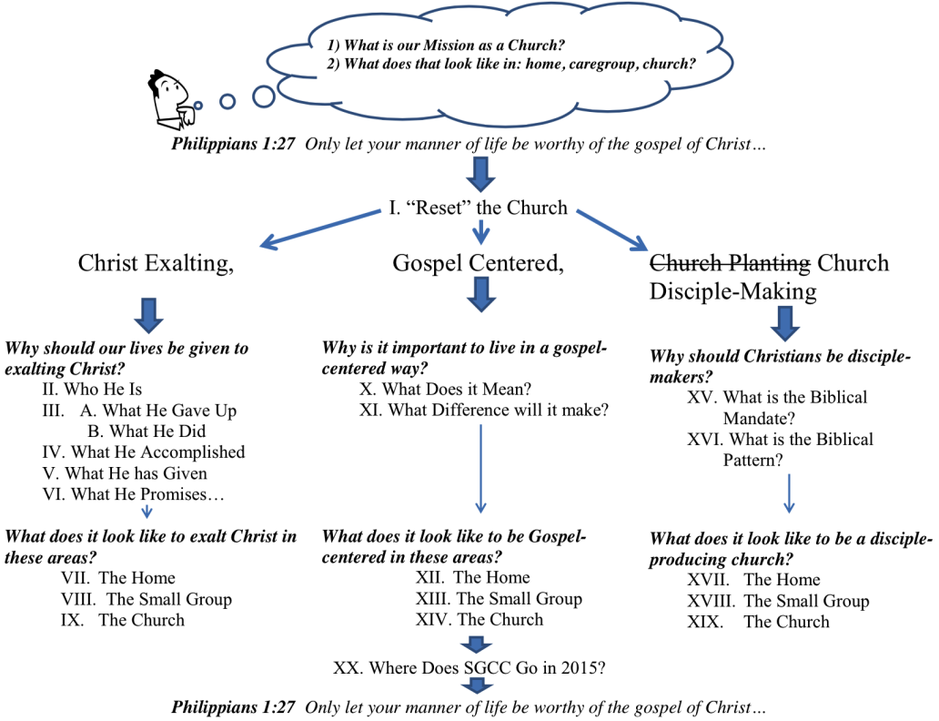*“No aspect of your identity is self-referential…Your opinion of yourself is far less important than God’s opinion of you, and accurate self assessment is derivative of God’s assessment. True identity is God-referential.”* -David Powlison, The Therapeutic Gospel. The Journal of Biblical Counseling.