***“3 Essentials to Gospel Centered Small Groups”***

**A) Willingness to be Community**

**1) Our Grounding:**

Ephesians 2:15-22

*Why did God do this?*

Purpose of Community = Ephesians 2:7

**2) Our Need:**

Image bearers: Gen 1:27

**3) Our Expression:**

Q – *“The world will not recover from the community of God’s people living lives to glorify Jesus”* Bill Clem

**B) Willingness to Fight**

**1) Our Grounding:**

YAHWEH: Exodus 15:3

Hebrews 12:3-4; Luke 22:42-44; Luke 22:31-32

**2) Our Need:**

1 Peter 5:8-9; 1 Peter 2:11; 1 Timothy 6:12; 2 Timothy 4:7-8

**3) Our Expression:**

• Encourage/Exhort • Pray: • Share in bearing burdens

Hebrews 3:13 James 5:16 Galatians 6:2

1 Thessalonians 5:11

• Show hospitality • Serve each other • Inspire:

1 Peter 4:9 1 Peter 4:10 Heb 10:24

* How do we do all these things? = small groups!

Hebrews 10:24-25

**C) Willingness to Love/Care**

**1) Our Grounding:**

**Isaiah 53:10**  Yet it was the will of the LORD to crush him; he has put him to grief; when his soul makes an offering for sin, he shall see his offspring; he shall prolong his days; the will of the LORD shall prosper in his hand.

**Isaiah 53:11**  Out of the anguish of his soul he shall see and be satisfied; by his knowledge shall the righteous one, my servant, make many to be accounted righteous, and he shall bear their iniquities.

*Who are His Offspring? Why was He satisfied?*

**Hebrews 12:2**

**2) Our Need:**

***“To be a caregroup means to provide care for those in the group but also to “care about those around us”***

**3) Our Expression:**

*How?* Same way they did it in the early church – Sunday big meeting/ small groups!

Acts 2:46-47; Acts 5:42

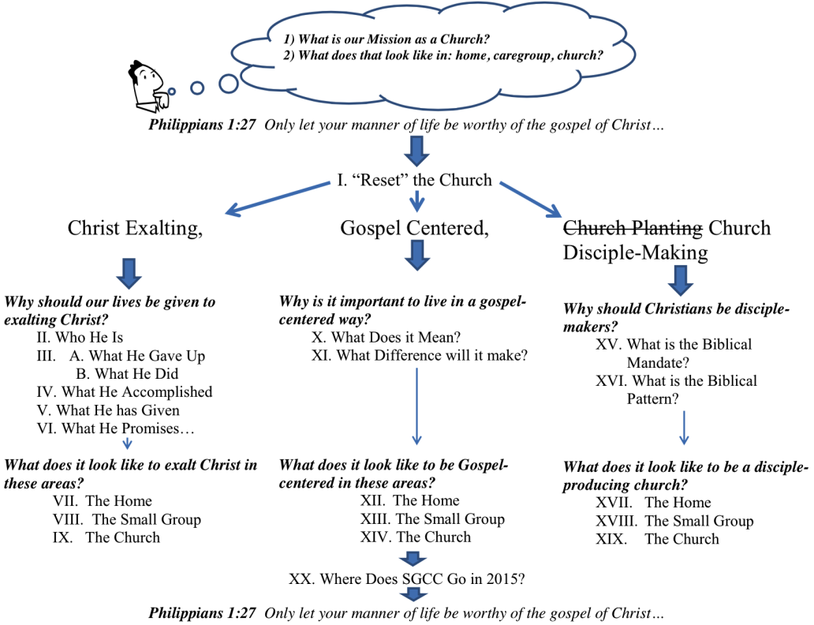**Quotes:**

*“Community, therefore, is an expression of who God is in Trinitarian relationship and a testimony to his love in redeeming us as a people through Jesus. We must conclude that if God created community for this purpose, it should be an essential part of every Christian’s life. The marginalization of community within the church and culture has not come from conviction but from apathy and isolation brought on by sin. Isolation is our response to sin. Community is our response to reconciliation.”*

Brad House, Community: Taking Your Small Groups off LifeSupport.