***“Our Mission”***

Mt 28:18-20

**I. Why ‘disciple making’ rather than church planting?**

Romans 15:23-24 - Paul’s/NT method

**II. What is the Clear Mission of the Church?**

Def: *a task or job that someone is given to do; a specific task with which a person or a group is charged*

**A) What Mission is/ is not**

*What is commanded by Jesus and mandated as the “mission of the church?*

**ANSWER: =** Make _____________________.

**B) Why Make Disciples?**

**1) The Reality of Hell**

2 Thessalonians 1:7-9

**2) The Worship of all Nations**

… when mission comes to an end …

Revelation 7:9-10

**III. How did Jesus ‘disciple’ His disciples?**

**A) Truth**

**B) Investment**

Mark 6:31-32 Luke 22:31-32

**C) Patience**

**D) Obedience**

1 John 5:2-3

**E) Correction**

Matthew 16:23; Luke 22:25-26

**F) Love**

John 13:1; John 17:23-24

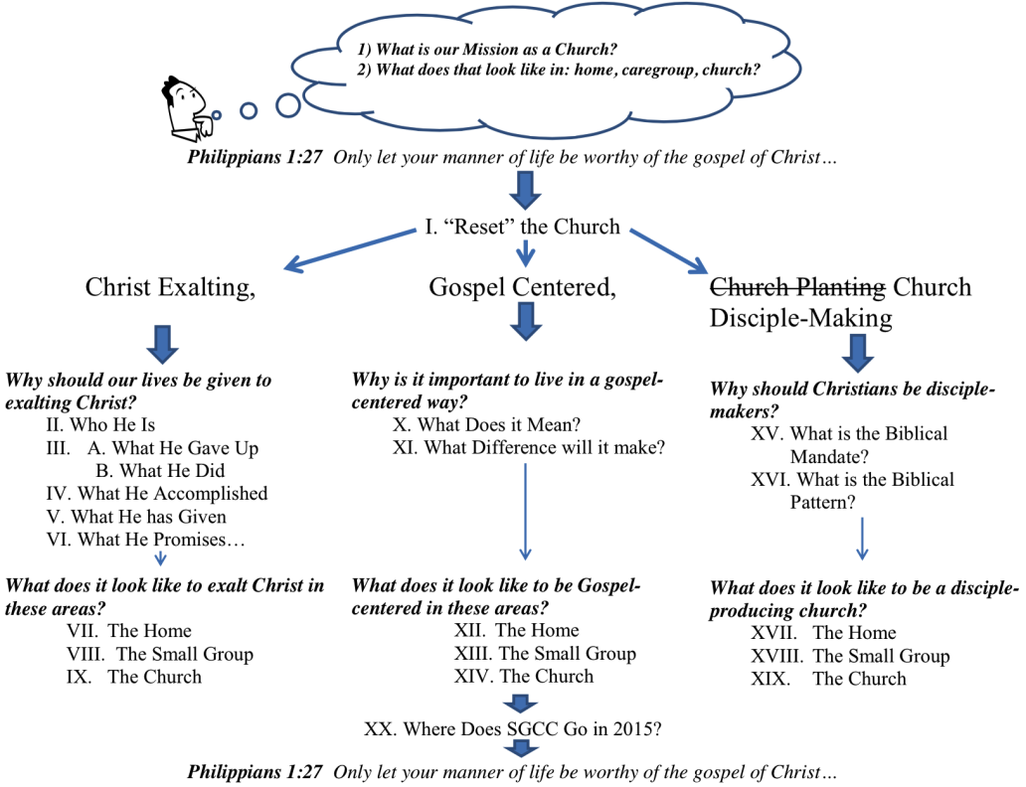**Quotes**:

*“We believe that the church is sent into the world to witness to Jesus by proclaiming the gospel and making disciples of all nations.”* Kevin DeYoung & Greg Gilbert, *What is the Mission of the Church*.

*“… it becomes clear that mission is in fact a means to an end, the end being a total focus on the worship and the glory of God in our Lord Jesus Christ.”* Andreas Kostenberger

*“Missions exists because worship doesn’t. Worship is ultimate, not missions, because God is ultimate, not man. When this age is over, and the countless millions of the redeemed fall on their faces before the throne of God, missions will be no more.”* John Piper, *Let the Nations be Glad,* p. 15.