**“Follow … Our Goal His Desire”**

**Ephesians 5:17-21**

**Follow: *Every member a Spirit-led worshipper and practitioner***

**I. The Importance of the Ministry of the Holy Spirit**

**“Continually be filled”**

**II. Allowing the Spirt to have “Sway”**

**A) What that *does not* mean!**

**1) You lose control**  1 Corinthians 14:32, 39-40

**2) You stray from Scripture** 2 Timothy 3:16-17; 2 Peter 1:3

**3) You claim foolishness as faith**

**4) You ignore hermeneutics**

**5) Exalt Secondary Doctrines** John 16:13-14

**B) What “allowing the Spirit to have sway” *does* mean…**

**1) Relinquishing Control to God**

a) “If Scripture says it, I believe it, I will do it”

1 Corinthians 14:1; 12:30-31; 14:39

b) I am captive to Scripture as written by the Holy Spirit

Luke 6:27-28; Colossians 3:13

c) The Holy Spirit is God, I am not

**2) Intentional Pursuit of the Spirit**

a) personally

*And do not get drunk with wine, for that is debauchery, but be filled with the Spirit*

b) corporately 1 Corinthians 12:4-7

**3)** **Recognize the “Broad” work of the Spirit**

Narrower: 1 Corinthians 14:1

Broader: - Galatians 5:22-23

**4) Intimacy with God** Romans 8:15-16; Ephesians 6:18; Jude 1:20

**5) Consistency with Doctrine and Practice** 1 Corinthians 14:18; Titus 2:1; 2 Tim 1:13

**6) Spirit dominates your speech and behavior** Eph 4:30

**7) Empowered to Accomplish God’s Desires**

Acts 4:8, Acts 4:31

**8) Experience Active presence Of the Holy Spirit**

**9) Fills us with Exuberant Joy in Worship**

Acts 13:52; Romans 14:17, 15:13; 1 Thessalonians 1:6-7

**10) Faith: A Willingness to risk/trust**

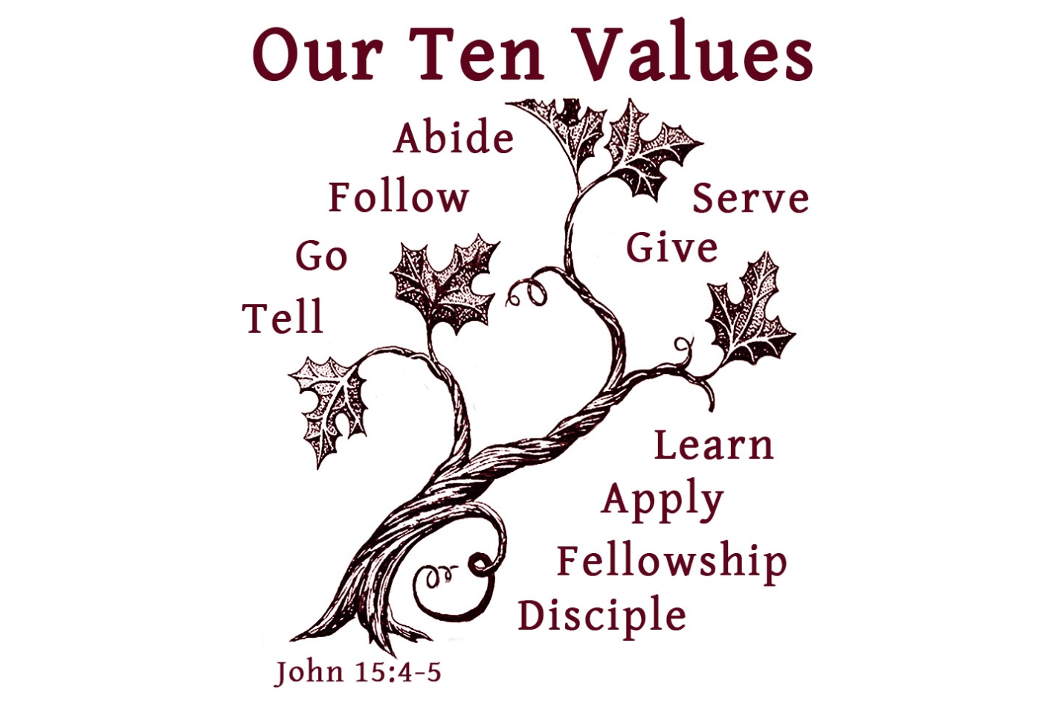

**Quotes**

*“Honoring the Holy Spirit has, I believe, has been the secret of every revival movement in Christendom from the start, whether or not the actual words have been used. Believers honor the Holy Spirit when they give him his way in their lives and when his ministry of exalting Christ and convincing of sin, sinking them ever lower and raising Christ ever higher in their estimate, goes on unhindered and unquenched. The records of all fruitful times in the church’s past confirm this.”*

JI Packer, *Keep in Step with the Spirit*, p.188.

***“****So my bottom line answer—and I've been asked this a lot—is to follow in general the pattern of the Bible, namely, pray to the Father in the name of Jesus by the power of the Spirit, that is, in reliance upon the help of the Spirit.*

*But, from time to time, "Maranatha! Lord Jesus, come!" is not a bad prayer. And "Holy Spirit, fall upon us and grant us a fresh baptism" is not a bad prayer.*

*So, in general, pray to the Father; but occasionally, to express their Personhood and your own love for them, telling the Spirit and the Son that you love them and that you would like them to come in fullness is a good thing.”*

John Piper